Step1.The pantograph connects with the red socket and the red plug conducts the positive electricity and the black plug connect with the negative electricity.
Please insert the red connector into the red socket, insert the black plug into the socket which conducts the negative electricity.
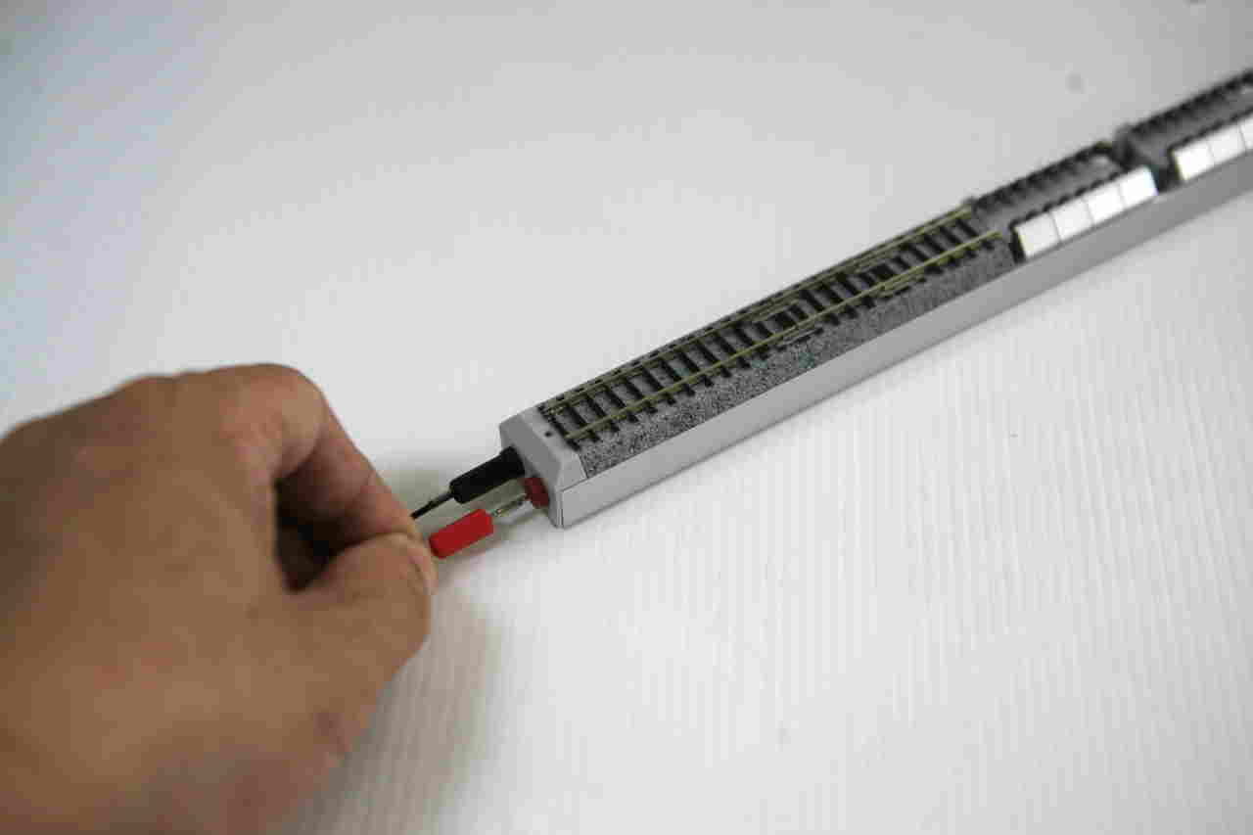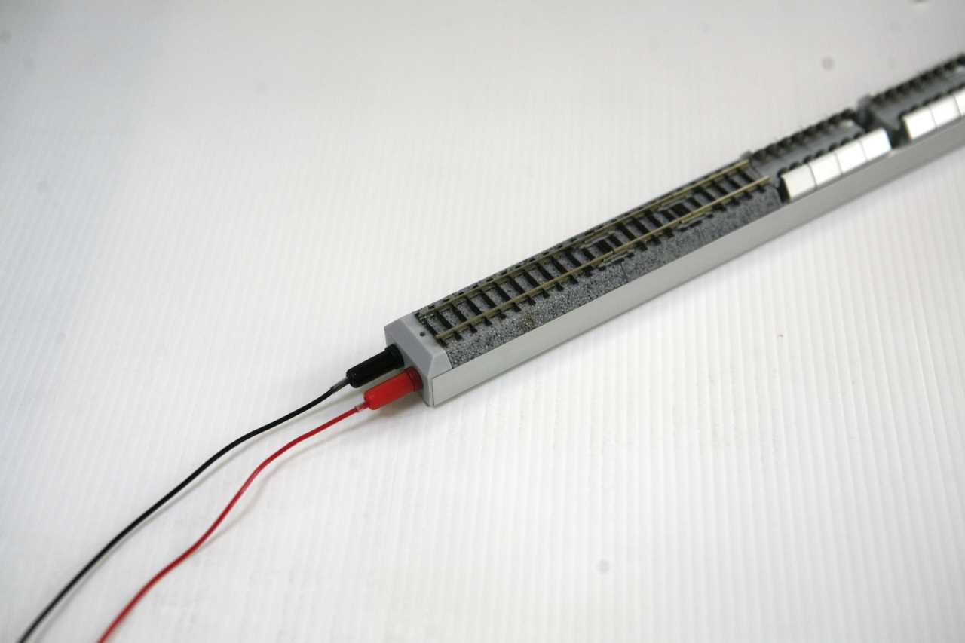

Step 2. Please rise up the pantograph then switch the electricity from the rail to the pantograph. The switch structure depends on the manufacturer, different manufacturers has a different design as the pictures.
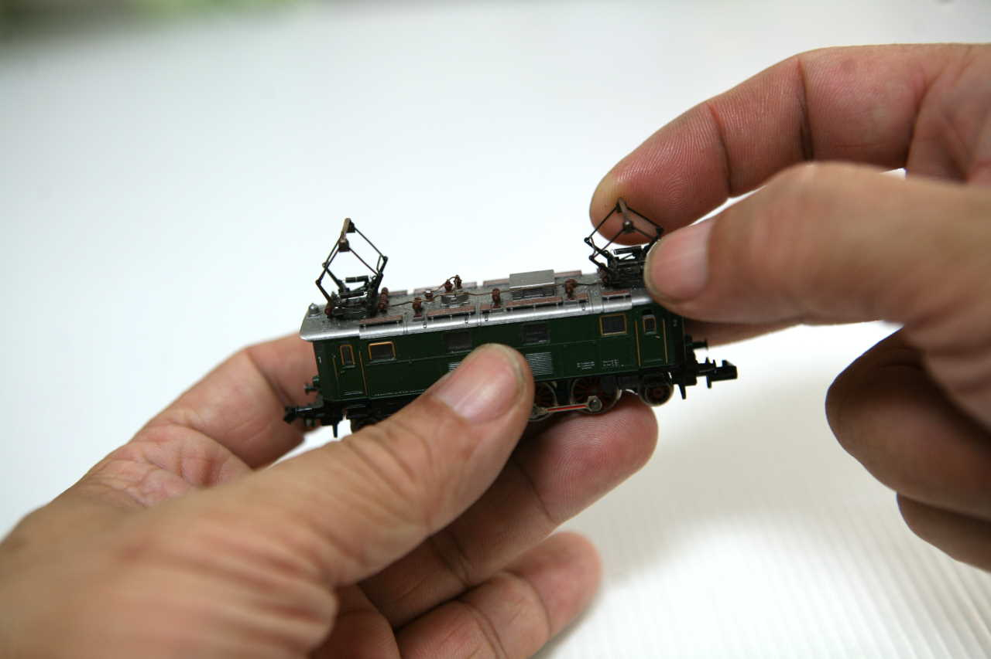 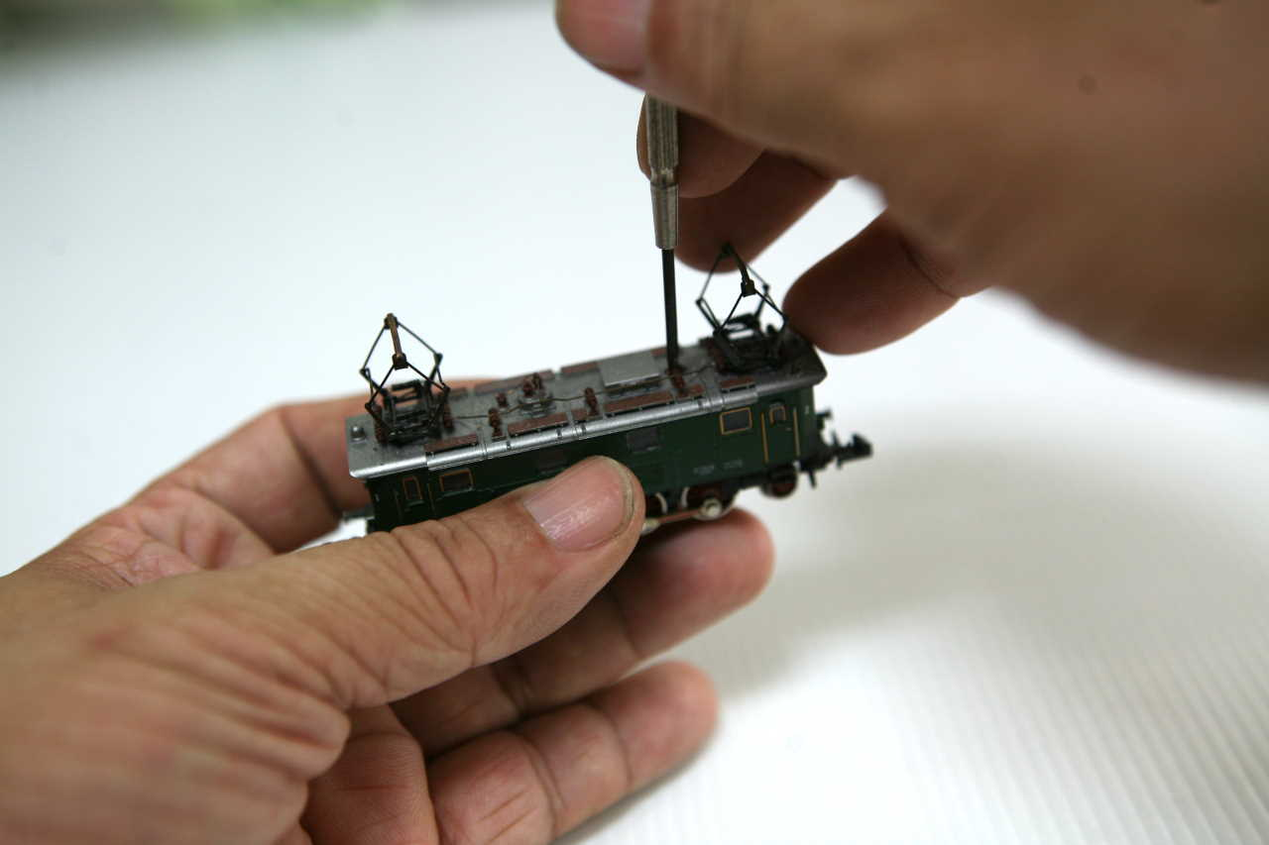
Rise up the pantograph. Switch from the track to pantograph.
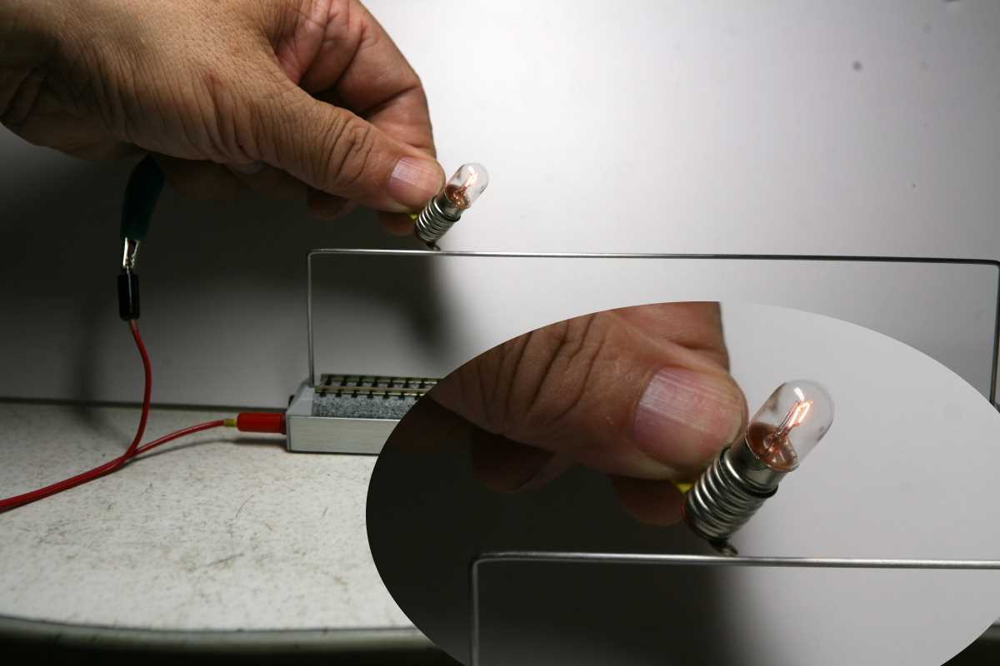
The red connector connected with the overhead wire.

Step 3. Please make sure the electric locomotive which side conduct the positive charge (electricity), usually the locomotive body has marked the symbol “1” and “2” or “V” and “H” on the front and back. The symbol “1” is positive charge and please let it face to the power jack.
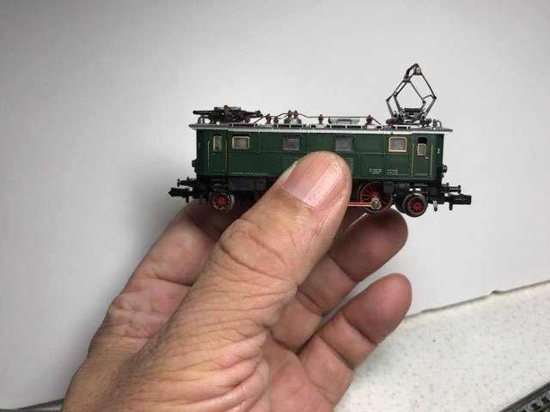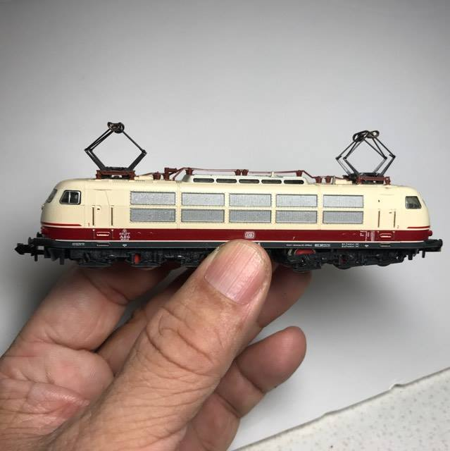
The shell marked No1.
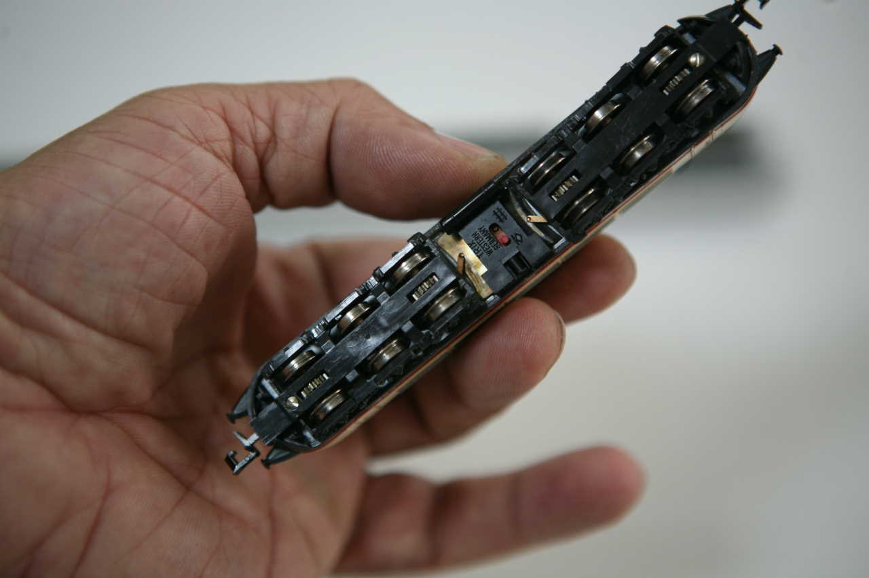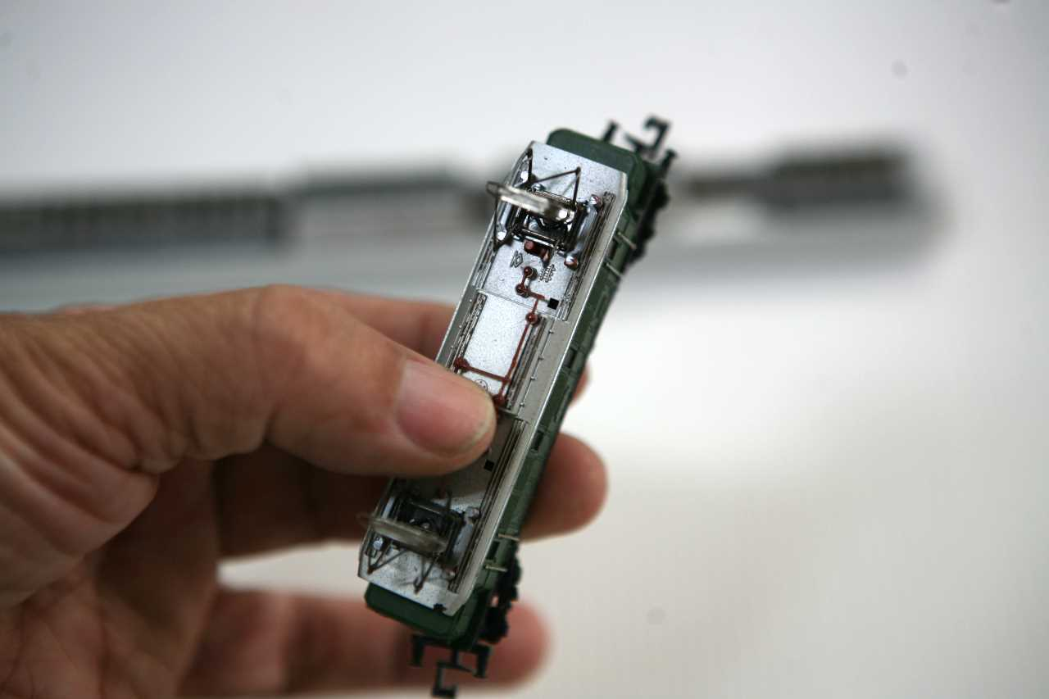
Many kind of the switchers depend on the manufacture.
PS: Please very carefully to make sure the electric which side conduct the positive electricity via the pantograph is very important, please read each electricity locomitve user menu carefully.

Step 4. Put the electric locomotive on the bearing sets then adjust to fix the drive wheels.
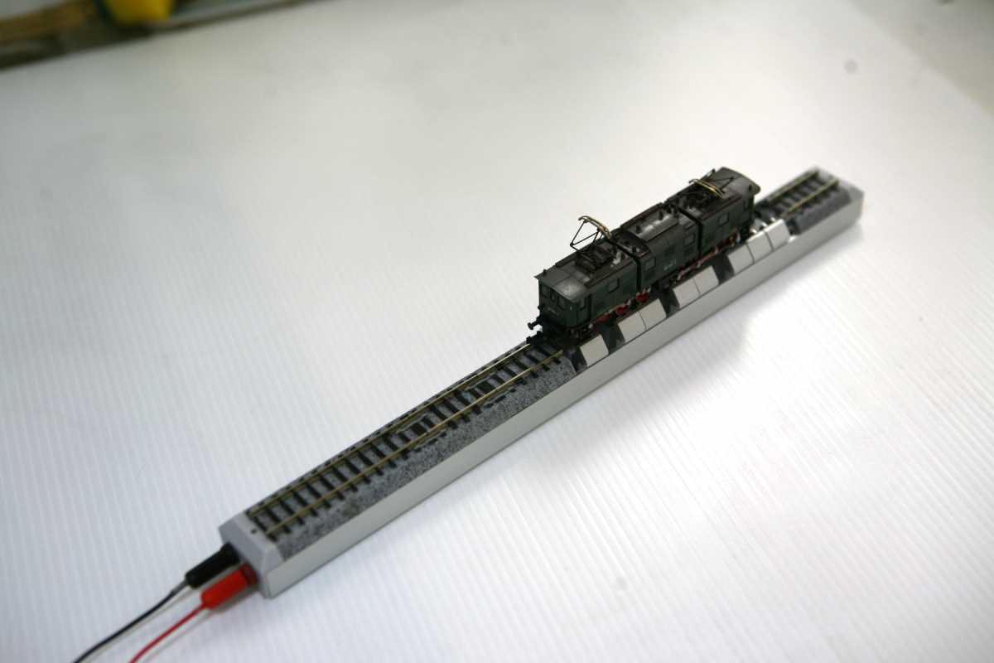

Step 5. Insert the overhead wire into the both hole then turn on the power.
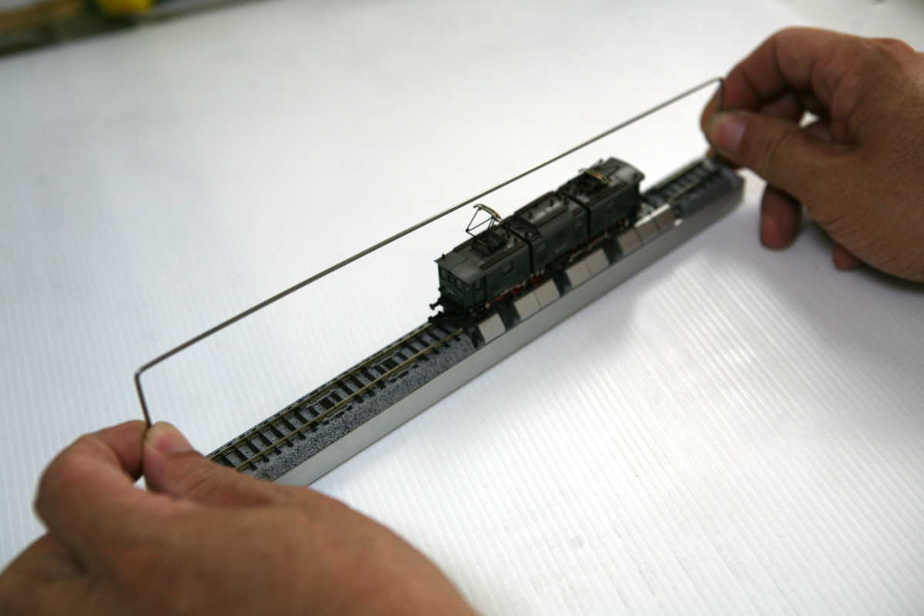
Put the electric locomotive on the bearing sets then install the pantograph.

